FinTech Lab Week 4

Open up springboot and create a Maven Project named bndb with dependencies:

* Spring Web
* MySQL Driver
* Spring Data JPA

Generate, download and extract the maven file to the desired location.

Go to: src/main/resources and open application.properties and modify the file to:

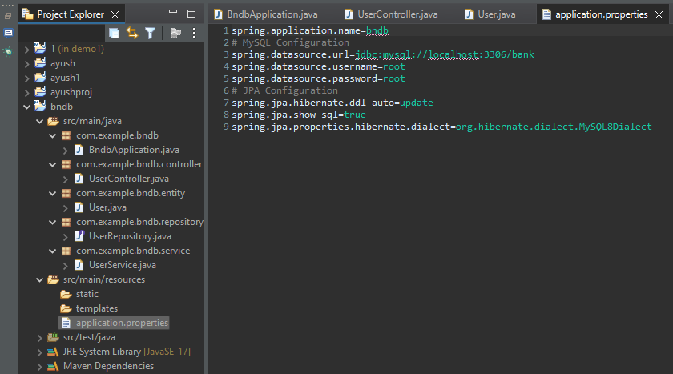

Then create a new package called com.example.bndb.entity and create a class in that package called ‘User’ as follows:

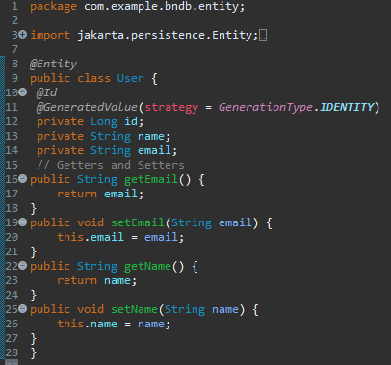

Create another package called com.example.bndb.service and inside it create a class called UserService as follows:

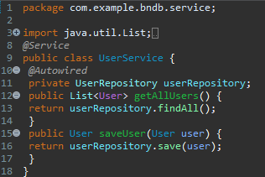

Create another package called com.example.bndb.repository and create a class UserRepository

